The Cold, Hard Truth About 5G Conformance Testing
(or 4 Tips for 5G Conformance Testing

Of all the challenges mobile device and base station manufacturers are up against in the 5G rollout, passing conformance and device acceptance tests is among the most daunting.

By Dylan McGrath, Senior Industry Solutions Manager, Keysight Technologies

Ten years ago, during the transition from 3G to 4G, handset and base station makers had to overcome significant hurdles. However, the changes between 3G and 4G were small compared to the rollout of 5G. The transition from 4G to 5G is considerably more disruptive, involving many more changes and the incorporation of far more innovative and complex technologies.

For starters, 5G devices operate at higher frequencies with wider transmission bandwidths, and connections require entirely new access technologies. Mobile devices must be able to handle dual connectivity, receiving both 4G LTE and 5G signals, and then aggregating the streams to create a seamless, harmonious user experience.

For conformance test, that is just the beginning of the complexity involved. One of the most frequently cited benefits of 5G is a surge in the number of expected use cases, resulting in a corresponding exponential increase in the number of test cases. 5G’s Frequency Range 2 (FR 2), spanning from 24.25 GHz to 52.6 GHz, brings a significant increase in test complexity. To top it all off, 5G remains a moving target — conformance test requirements and methods are not yet complete, while the standards continue to evolve.

Here are four tips to prepare for 5G conformance and acceptance tests:

Tip number one – use the minimum requirements as a guide
In order to understand the 5G specifications, it is important to look back at the process that generates them. The 3rd Generation Partnership Project (3GPP) radio access network (RAN) working committees define the conformance goals (Table 1).

5G NR originates with a vision of pervasive connectivity, extreme data rates, and low latency with highly reliable networks. The IMT-2020 vision, created by the International Telecommunications Union (ITU) working with the International Mobile Telecommunications (IMT), has three primary use cases for 5G NR: enhanced mobile broadband (eMBB), ultra reliable low latency communications (URLLC), and massive machine-type communications (mMTC).

The 3GPP study item technical report (TR) 38.913, describes the key performance indicators (KPIs) for the different deployment scenarios, as well as vehicle-to-everything (V2X) requirements. KPIs include targets for peak data rates, spectral efficiency, latency, reliability, and user equipment (UE) battery life.

The RAN working groups develop the 5G NR specifications based on the IMT-2020
goals. 5G NR documents are available in the 38.xxx series documents located on the 3GPP website.

 | Study items for new radio access technology | Specifications
RAN1  Radio layer 1 | TR 38.802  Physical layer aspects | TS 38.201 – TS 38.215
RAN2  Radio layer 2  and Radio layer 3 | TR 38.804  Radio interface protocol aspects | TS 38.300 - TS 38.331
RAN3  Radio network | TR 38.801  Radio access architecture and interface | TS 38.401 – TS 38.474
RAN4  Radio performance and protocol | TR 38.803  RF and co-existence aspects | TS 38.101 – TS 38.173 (+ TS 38.307)
RAN5  Mobile terminal conformance tests | TR 38.80x | TS 38.508 – TS 38.533
Table 1: 3GPP RAN working groups generate technical reports and technical specifications.

Conformance tests ensure a minimum level of performance in UEs and base stations. Table 2 lists the 3GPP requirements documents. Conformance tests validate transmitter characteristics, receiver characteristics, and their performance.

Additional tests for devices include radio resource management (RRM) and protocol testing. Base station tests are structured around radio frequency (RF) parameters. UEs have a much longer list of conformance requirements that add radio access, signaling, and demodulation tests. UEs must also undergo validation by certification organizations, such as the Global Certification Forum (GCF) and PCS Type Certification Review Board (PTCRB), to ensure 5G commercial devices comply to the latest 3GPP specifications.

To ensure UE devices operate as expected on a specific network, they must pass acceptance tests by mobile network operators.

Conformance test specifications originate from the minimum requirements specified in the 3GPP RAN2 and RAN4 documents. The conformance specifications take into consideration the test measurement uncertainty and test tolerance.

Operators and device and base station original equipment manufacturers (OEMs) specify the test requirements for each test. The minimum requirement specification is more stringent than the conformance specification. Designers can use the minimum requirement as a guide to test their 5G NR products until 5G NR conformance test requirements are complete. The minimum test requirements ensure that 5G products pass the final conformance test cases.

Base station or UE conformance test specification | Specification description
Base stations  TS 38.141-1  TS 38.141-2 | Part 1: Conducted testing in FR1  Part 2: Radiated testing for specific base station configurations in FR1 & FR2
Devices  TS 38.521-1/2/3/4  TS 38.523-1/2/3  TS 38.533 | 5G NR UE radio transmission & reception:  - Range 1 standalone – FR1 conducted tests  - Range 2 standalone – FR2 radiated tests  - Range 1 & 2 interworking operation with other radios (NSA)  - FR1 conducted & FR2 radiated  - Performance requirements (SA and NSA)  - FR1 conducted & FR2 radiated  5GS UE protocol conformance:  - Protocol  - Applicability of protocol test cases  - Protocol test suites  5G NR RRM (SA and NSA):  - FR1 Conducted & FR2 radiated

Table 2: 3GPP conformance tests for base stations and devices.

Tip number two – address test system complexity with high-performance instruments
The lower frequency tests in 5G NR Frequency Range 1 (FR1) are similar to 4G LTE tests, but FR2 testing stresses the test solution in many new ways. The test equipment required to test the FR2 range needs to cover wider frequencies and bandwidths. The requirements are up to 60 GHz for measuring spurious emissions, and up to 1.6 GHz bandwidth to support inter-band carrier aggregation.

Conformance requirements state that all FR2 device and base station tests — as well as some FR1 base station tests — are radiated tests. This requires over-the-air (OTA) testing, which introduces additional test challenges, including greater path loss and higher measurement uncertainties that make it challenging to achieve measurement accuracy.

Pre-conformance and conformance tests require a calibrated OTA test solution that covers all the requirements outlined in the 3GPP conformance documents listed in Table 2. Example tests include transmitted power, signal quality, intermodulation, spurious emissions, and blocking tests.

A test solution for millimeter-wave (mmWave) designs needs to accommodate higher frequencies with wider channel bandwidths. The solution must also have an adequate signal-to-noise ratio (SNR) to detect and demodulate 5G signals accurately. When testing transmitters, for example, SNR is critical in the signal analyzer to ensure accurate error vector magnitude (EVM) and adjacent channel leakage ratio (ACLR) measurements.

In an OTA test setup where path loss is an issue, a vector signal generator (VSG) with high output power and low EVM will ensure adequate SNR for testing 5G receivers.

A selectivity and block test setup requires multiple mmWave signal generators to provide the fixed reference channel, a modulated interfering signal, and a continuous wave (CW) signal. High output power is also important to overcome higher path losses at mmWave frequencies.

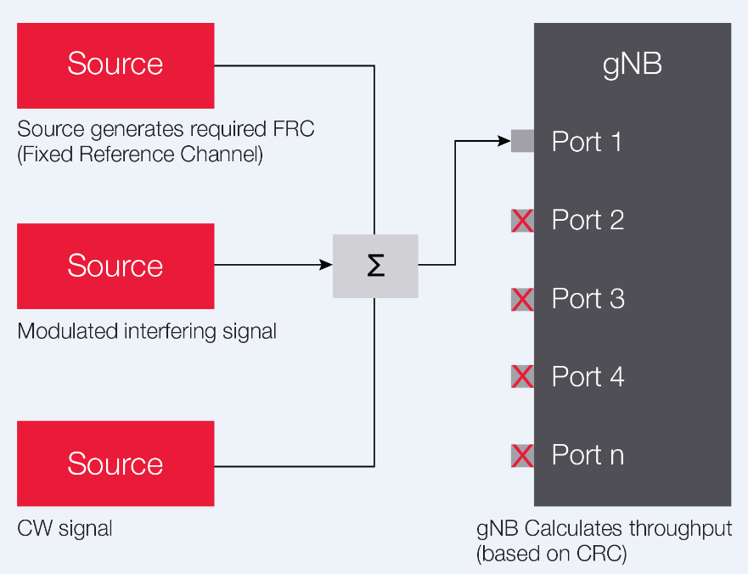

Figure 1: Base station receiver intermodulation conducted test setup for part 1 (part 2 is OTA).

When specifying a 5G test solution, it is also important to select test equipment that has adequate range to cover the requirements from sub-6 GHz to the different mmWave operating bands. Since many tests require multiple sources for receiver tests and multiple analyzers for transmitter tests, a modular platform will reduce the test footprint and simplify the test setup (Figure 1).

Tip number three - ensure test case coverage with standard platforms
5G NR aims to support many different use cases and deployment scenarios over FR1 and FR2 operating bands. The test combinations create a vast matrix of test cases (Figure 2).

For example, 5G NR can operate in standalone (SA) or non-standalone (NSA) mode. In standalone mode, the 5G NR connects directly with the 5G next-generation core (NGC) network and operates independently of 4G. However, it will take time to roll out 5G networks, and 5G NR will rely heavily on the 4G infrastructure to maintain connectivity as 5G devices travel through the network.

Devices need validation for one or multiple deployment options. Evolved Universal Terrestrial Radio Access (E-UTRA) and 5G NR dual connectivity (EN-DC) also require testing. With the addition of multiple-input multiple-output (MIMO) and multiple carrier aggregation combinations across various operating bands, this equates to more than 1,000 UE test cases.

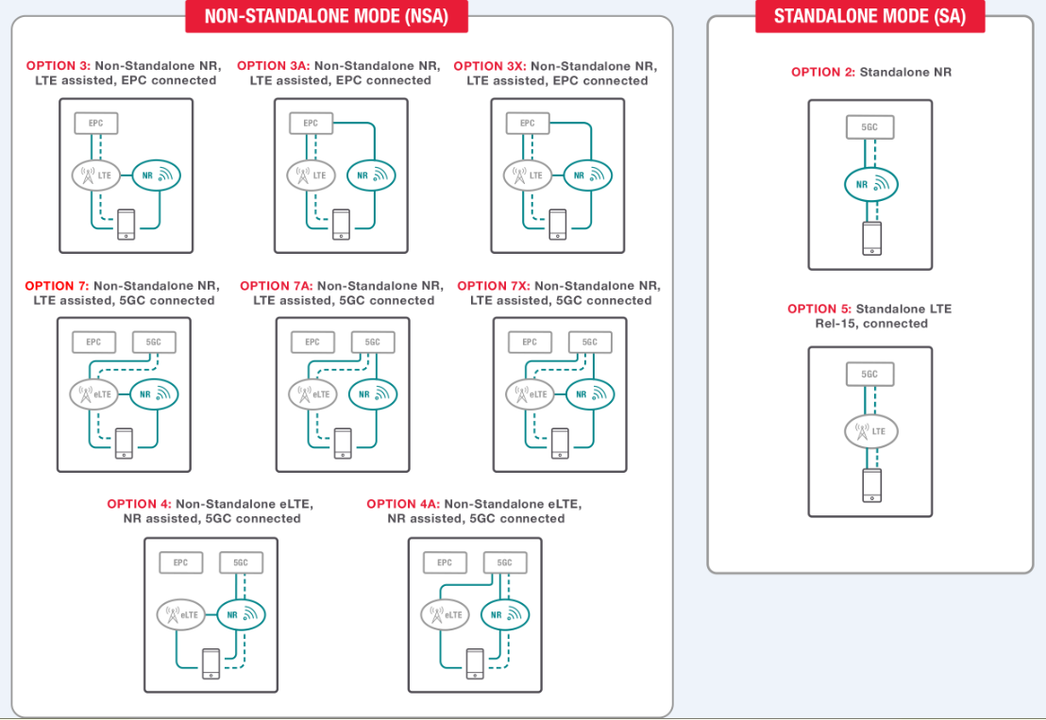

Figure 2: 5G NR deployment options.

A common hardware platform that scales across frequency ranges and UE conformance tests — including RF, RRM, and protocol — provides the scalability needed to maximize 5G test case validation coverage.

Standardization on a common platform provides additional benefits. Leveraging test platforms across the workflow enables 5G designers to resolve and validate issues early in the design phase. Using the same test platform in pre-conformance and conformance testing will reduce issues and speed up test times (Figure 3).

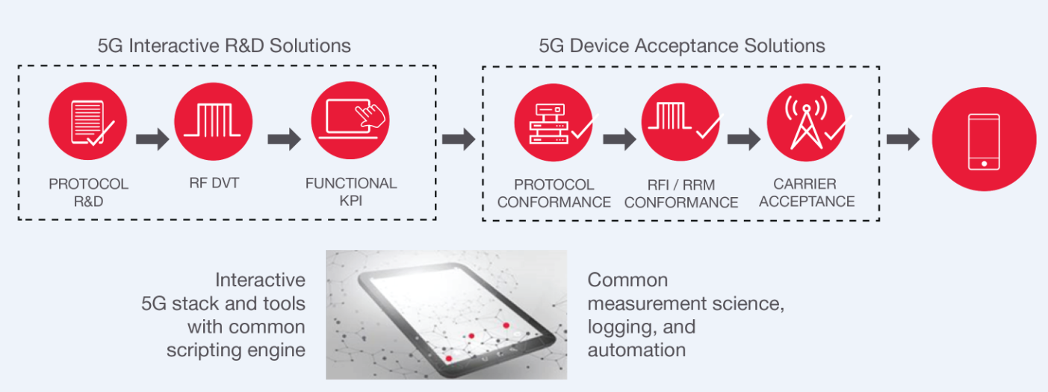

Figure 3: Using the same test platform across a device workflow.

Tip number four – stay current on 5G NR standards
Preparing for the next phase of 5G NR is critical. While Release 15 was approved back in June 2018, conformance testing for various use cases and network deployment options are still work in progress. Carrier aggregation, FR2, and RRM test cases are far from 100 percent complete.

Release 16 was originally was to be release in March of this year. 2020. However, circumstances force a postponement. It was pushed out to June 2020. To date, it still has not been released.

When it is released it will continue with 5G NR optimization, new use cases, and identifies new types of services, devices, deployment models, and spectrum bands. There is an emphasis on URLLC enhancements for industrial IoT, utilization of unlicensed bands, cellular V2X, UE positioning, and power efficiency. As the standard continues to evolve, test solutions need to support higher frequencies, wider bandwidths, and new physical layer features.

Future-proof investments in test equipment that can evolve as the standards change. Consider how quickly the test vendor can provide software releases to update to the latest test cases.

As standards evolve to higher frequencies and wider bandwidths, scaling the test hardware is a physical limitation. One strategy is to purchase or lease test equipment that has broader coverage initially. Another approach is to use test equipment that easily scales as the requirements change.

Conclusion
These four tips for 5G conformance testing can help to ensure 5G products are deployed successfully and on time. While testing to minimum requirements will ensure that products pass conformance testing, test solutions and methods will need to continue to evolve as the standards do. Therefore, careful selection of test equipment is essential — an emphasis on flexible and common test platforms with enough performance and capabilities to address 5G’s most challenging test scenarios — is foundational to success in the 5G era.

About the Author
Dylan McGrath is a veteran technology journalist and former editor in chief of EE Times. He is now a senior industry solutions manager at Keysight Technologies.

