Overcoming Designer Challenges When Working with OCXOs
Common Timing Challenges for Designers and How to Deal With Them…

By Jim Holbrook, and Jeff Gao,

OCXOs (oven-controlled oscillators) offer the pinnacle of performance in timing with stability around ±50 ppb (parts per billion) or better. Because some OCXOs provide Stratum 3E level timing stability, they are used in high-throughput communications networks that demand more stringent timing performance, which increases with each new generation. Moving forward, OCXOs will be essential for emerging 5G and IEEE 1588 synchronization applications that require higher performance and will support mission-critical services like self-driving vehicles.

How do OCXOs achieve this stability?
Ambient temperature variation is one of the main factors that adversely affect oscillator frequency stability. OCXOs are designed to maintain tight frequency stability under ambient temperature variation by encasing the resonator and oscillator IC in an enclosure that contains a heating element to maintain the temperature as constant as possible. But, even though these “ovenized” devices are engineered to keep the internal temperature constant, the stability of traditional OCXOs can be impacted by variations in the ambient temperature – especially when the temperature changes quickly. This can happen because of imperfections in the enclosure insulation or because of heater control lag.

That is why designers make painstaking decisions on where to place the oscillator on the board. OCXOs are often placed in a corner, away from fans which cause airflow-induced thermal shock and away from the main processing unit which can generate significant heat. But, there are tradeoffs to moving the oscillator into the corner and away from the chip that it is clocking, such as increased routing complexity and potential signal integrity issues. Some designers must go through a couple of board layout iterations just to figure out where to place the OCXO.

In many cases, the OCXO is covered with a special mechanical shield for thermal and air flow isolation. However, these covers are typically not off-the-shelf items. They require finding a specialized vendor to design and make the cover, additional board space, and extra manufacturing steps to adhere the cover. All of this takes time and money, and they still are not fool proof.

Additionally, even with all of these protective measures, the OCXO is still not safeguarded against other factors that affect stability and performance. Things like vibration, time (aging), and electrical noise such as supply voltage or load impedance can be problematic, as well. This makes timing potentially the biggest source of failure in communications systems. To alleviate the headaches and risks of using OCXOs, a new MEMS-based OCXO platform has been introduced.

There is a solution
There are now MEMS-based solutions that provide an OCXO solution. They are precision timing devices, with ±5 ppb frequency stability over-temperature and are designed to provide better reliability and performance in dynamic conditions. Here are some features of OCXOs as compared to traditional quartz-based Stratum 3E OCXOs.

- Better performance in the presence of airflow and thermal shock
  - ΔF/ΔT dynamic stability: ±50 ppt/° C typical (ppt = parts per trillion)
  - Allan deviation (ADEV): 2^{e-11} under airflow
- 20 times better vibration resistance
  - 0.1 ppb/g
- No activity dips or micro jumps
- Smallest size
  - 9 x 7 mm footprint, 75 percent smaller
  - 5.7 mm height, 33 percent thinner
  - Also available in standard OCXO footprints for drop-in replacement of quartz OCXOs
- Semiconductor-level quality and reliability
  - Eliminates batch-to-batch inconsistencies of quartz OCXOs
  - No need to sample and test incoming lots
- Unmatched ease-of-use
  - No restrictions on PCB placement
  - No mechanical shielding required for thermal isolation
  - On-chip regulators – no need for external LDOs or ferrite beads
- Based on a programmable platform
  - Supports any frequency from 1 MHz to 220 MHz
  - Low voltage complementary metal oxide semiconductor (LVCMOS) or clipped sine-wave output

Solving long-standing board-level issues
Up to now, communication equipment makers had to rely on a delicate, hard-to-use timing device. The MEMS OCXO platform is designed to solve the long-standing problems of quartz OCXOs, which are sensitive to environmental conditions and often require protective measures. With fewer design considerations, equipment makers can reduce design complexity, speed development time, and accelerate revenue. Table 1 lists the design considerations between the two.

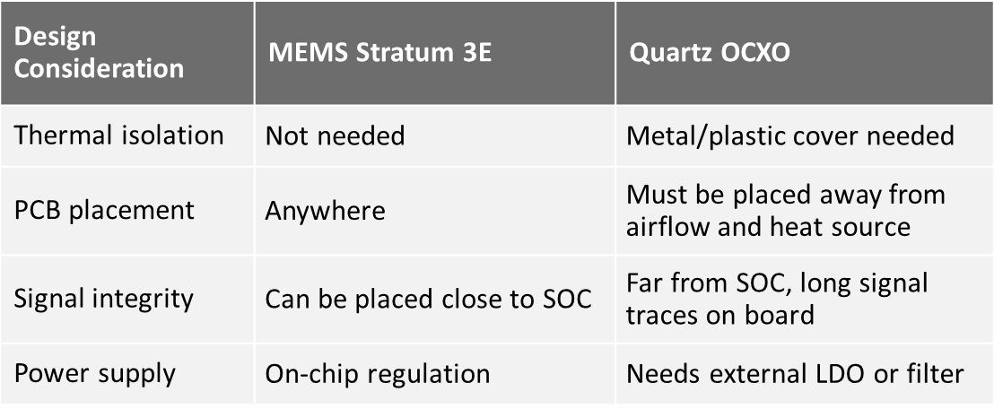
Table 1 – How MEMS OCXOs Solve Board-level Design Issues

Advantages beyond the board
Traditional OCXOs are limited in features. By contrast, MEMS OCXOs are built on a programmable architecture that enables flexibility, unique features, and short lead-times. In addition, MEMS OCXOs are superior in size, weight, and power (SWaP). This is important as electronic equipment becomes denser, packing more into less space while aiming to consume less power and require less cooling.

Following is a list of some of the unique features available with MEMS OCXOs.

- Any frequency from 1 MHz and 220 MHz with up to 6 decimals of accuracy. This allows designers to select the optimal frequency for their clock tree without any penalty in performance and lead-time.

- Two output types, LVCMOS and clipped sine-wave. This allows designers to choose an output that provides lower jitter (LVCMOS) or lower EMI (clipped sinewave, which has slower rise/fall times), depending on the application needs.

- Inter-integrated circuit (I²C) serial interface for in-system programmability. This digital control feature, that will soon be enabled, eliminates the board-level noise that is associated with traditional VCOCXOs, which use analog voltage control. This can also eliminate the low-pass filter required to interface the VCOCXO to the system-on-chip (SOC).

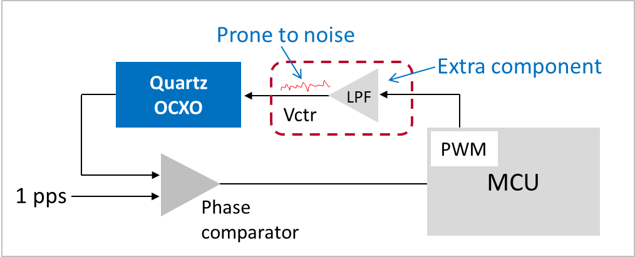

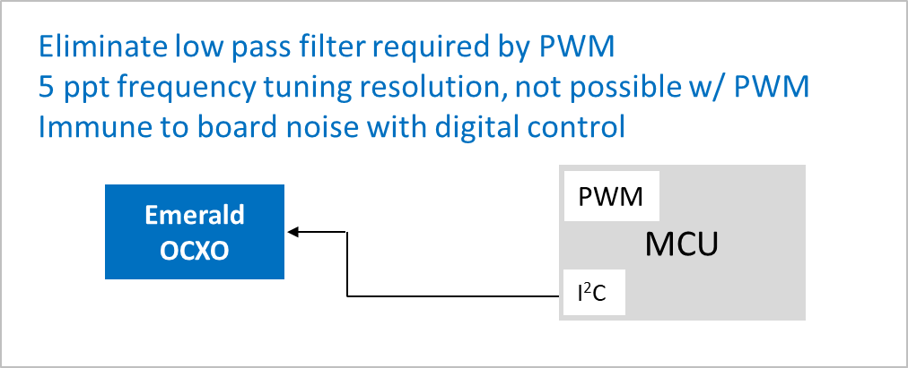

- Extended operating temperatures from -40° C to +95° C. This is the widest range for any OCXO and is ideal for outdoor 5G applications where thermal issues can cause system operation problems.

- Smallest size 9 x 7 mm footprint (75 percent smaller than quartz) and 5.7 mm height (33% shorter). This eliminates a major obstruction in chassis-based systems and is ideal for high-density small-form-factor systems. MEMS OCXOs are also available in three standard OCXO footprints that can be used as drop-in replacements for quartz.

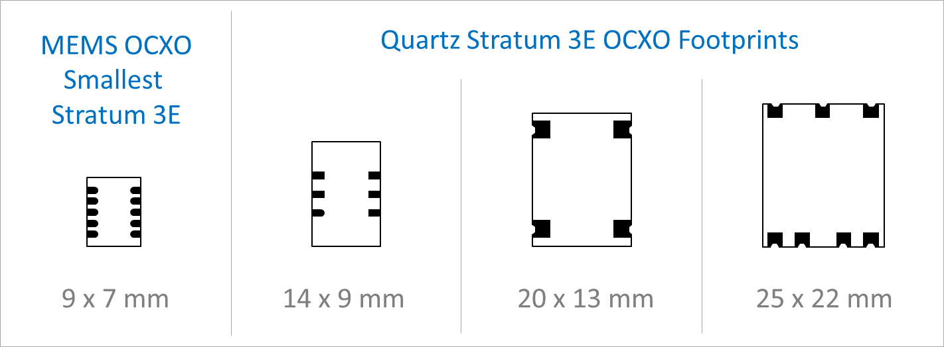

- Low power consumption at just 0.6 W, which is quite impressive considering these devices operate like small ovens. This is about half of what traditional power-hungry Stratum-3E devices consume, which is well over 1 W.

A more robust and stable Stratum 3E OCXO
Frequency stability is the most fundamental specification for an oscillator. This specification represents the deviation of output frequency due to external conditions. A smaller stability number means better performance. For OCXOs, frequency stability is typically expressed in ppb.

Temperature change is one of the main contributors to frequency deviation. Figure one presents a plot of frequency stability over temperatures from -40° C to +85° C, as temperature rises and as temperature drops (hysteresis), for four different similarly-rated devices. The performance of the MEMS OCXO device (shown in the green line) has a delta of just 1.5 ppb, which is four times better than the next closest OCXO.

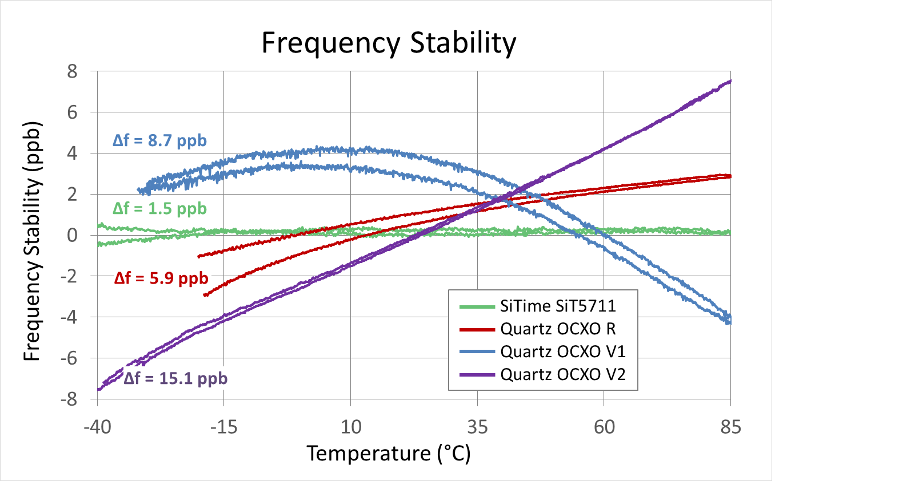
Figure 1. Plot of frequency stability over temperatures.
Frequency stability is key for synchronization applications such as Synchronous Ethernet (ITU-T G.8262) and IEEE 1588. This stability enables the oscillator to hold a stable clock when the system is in holdover state during network fault conditions. However, what is more important is the ability to maintain stability under real-world operating conditions, such as rapid temperature changes or other dynamic conditions that can affect the clock performance.

Another key metric for precision oscillators is frequency vs temperature slope (see Figure 2). Also known as ΔF/ΔT, this measurement quantifies the oscillator’s sensitivity to temperature change at 1° C increments. Here again, a lower number is better since it represents a deviation in frequency for a 1°C temperature change. The MEMS OCXO is rated at just 50 ppt/° C (ppt = part per trillion). The plot below shows the ΔF/ΔT performance of a MEMS OCXO compared to the three quartz OCXOs.

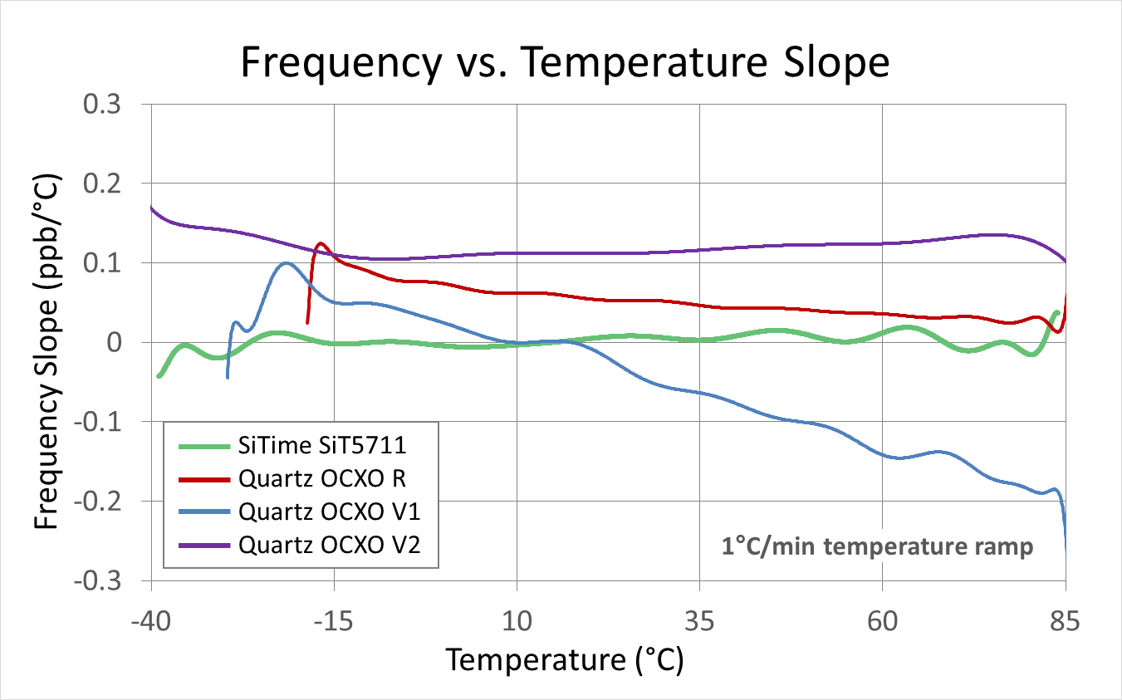
Many systems use high-performance components that generate substantial heat and require cooling fans. As processors cycle and fans turn on and off, there can be significant temperature transients in the system. Extreme external temperatures can compound internal ambient temperature and sometimes fans malfunction, causing temperature transients to become even more severe. Figure 3 shows how the MEMS OCXO and quartz OCXOs behave above the standard industrial operating temperature range.
Figure 2. Frequency vs. temperature slope.

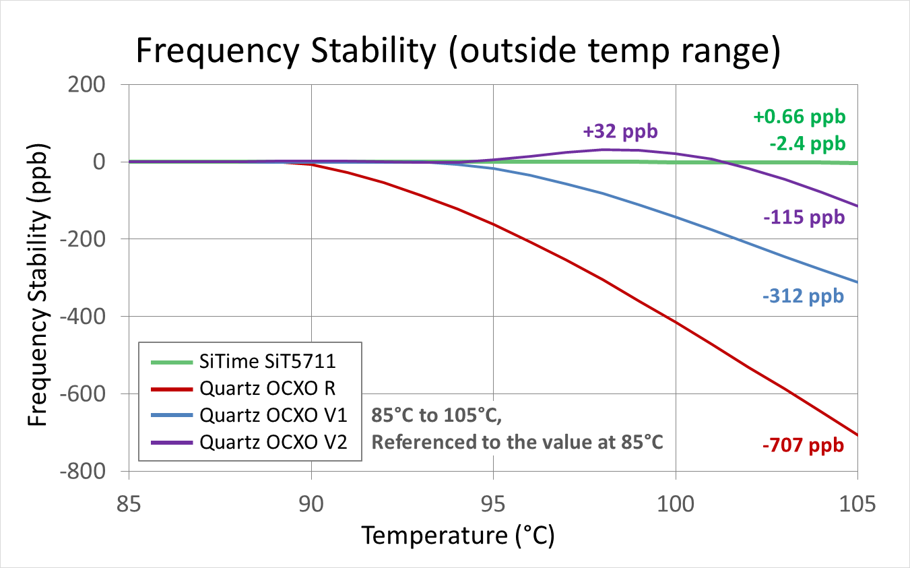
Another measure of frequency stability is Allan deviation (ADEV), which is a measure of oscillator short-term frequency stability. Compared to standard deviation, ADEV is used because it converges for more types of oscillator noise such as flicker frequency modulation and random walk frequency. Figure 4 shows how a MEMS OCXO device, with 2^{e-11} ADEV at 10-second averaging time, performs with airflow.
Figure 3. MEMS OCXO and quartz OCXOs outside normal operating temperature range.
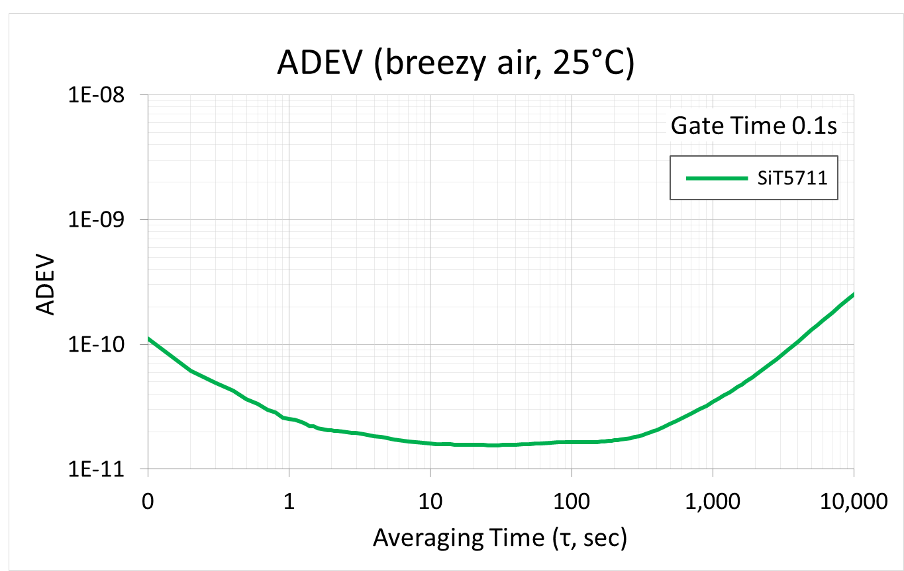
Figure 4. MEMS OCXO device, with 2e-11 ADEV at 10-second averaging time, performance.

Other common timing stability indicators include TDEV (time deviation) and MTIE (maximum time interval error). Both without and with airflow, MEMS OCXOs perform well within the specified ITU-T G.8262 EEC2 mask set as a standard for these measurements.

Robustness beyond temperature change
In addition to being resistant to airflow and rapid temperature change, MEMS OCXOs are virtually immune to vibration, which can also cause the frequency to shift. This resilience is critical since communications equipment is often exposed to vibration, especially when deployed outdoors. Wind, heavy vehicles, and trains are just a few examples of the many sources of vibration. MEMS OCXO products deviate by only 0.1 ppb/g, making them ideal for outdoor pole-mounted equipment.

Beyond all of the external factors that can wreak havoc on oscillator stability, there can be internal changes within the oscillator that change the oscillator frequency over time, even while external environmental conditions are kept constant. This is called aging. MEMS OCXOs have excellent aging specs at ±0.8 ppb typical daily aging and ±500 ppb typical 20-year aging.

Solving long-standing timing problems
MEMS OCXOs are engineered to solve the long-standing problems of quartz OCXOs. MEMS OCXOs are resistant to a wide range of dynamic conditions and are built to maintain stability in harsh environments where traditional OCXOs do not hold up. Equipment manufacturers no longer need to worry about the timing component being the weakest link in the system. And service providers can be less concerned about system failures and service interruptions due to timing.

MEMS OCXOs provide consistently stable performance from batch-to-batch and from one environment to the next. In addition to solving stability and other performance issues, MEMS OCXO solutions are easy-to-use and offer new features. These solutions increase reliability and performance, reduce design complexity, and eliminate the headaches associated with traditional OCXOs.

Bios
Jim Holbrook, Director of Customer Engineering at SiTime Corporation
Jim Holbrook is director of customer engineering at SiTime Corporation. He joined SiTime in June 2016. Prior to this, Holbrook was product marketing director of signal path solutions at Texas Instruments. He served for five years in the U.S Navy as a nuclear engineering instructor at the Submarine Training Facility in Norfolk, Virg., and was a nuclear submarine officer. For more information, go to: www.SiTime.com.

Jeff Gao, Director of Product Marketing at SiTime Corporation
Jeff Gao is director of product marketing for SiTime Corporation. He has more than 20 years of experience in solution marketing, business management and product development. He joined SiTime in October 2008 and has is responsible for all aspects of marketing including comms-5G strategy. Prior to Joining SiTime, Gao held executive and management positions at Amtel Corp and Cisco. For more information, go to: www.SiTime.com.

